DC COURSE PROJECT

D-division

Question 5

TEAM MEMBERS

417. ANANT CHAUDHARY

418. ADITYA PHATAK

419.SHREYAS MUTNAL

420. LOKESH PANDEY

|  |  |
| --- | --- |
| SI.NO | TOPICS |
| 1 | Problem statement |
| 2 | Features and specifications |
| 3 | Pin diagram of 4026 |
| 4 | Pin diagram of seven segment |
| 5 | Pin diagram of 555 timer |
| 6 | Circuit design |
| 7 | Alternate design |
| 8 | Simulation of circuit |
| 9 | Snapshot of circuit |

***Problem Statement***

***Design & implement a digital system using suitable logic for a scoreboard monitoring system.***

***FEATURES AND SPECIFICATIONS GIVEN***

|  |  |
| --- | --- |
| ***TOUCH OR SWITCH BASED INPUT*** | ***SWITCH*** |
| ***TYPE OF GAME*** | ***CRICKET*** |
| ***TYPE OF SEVEN SEGMENT USED*** | ***COMMON ANODE*** |

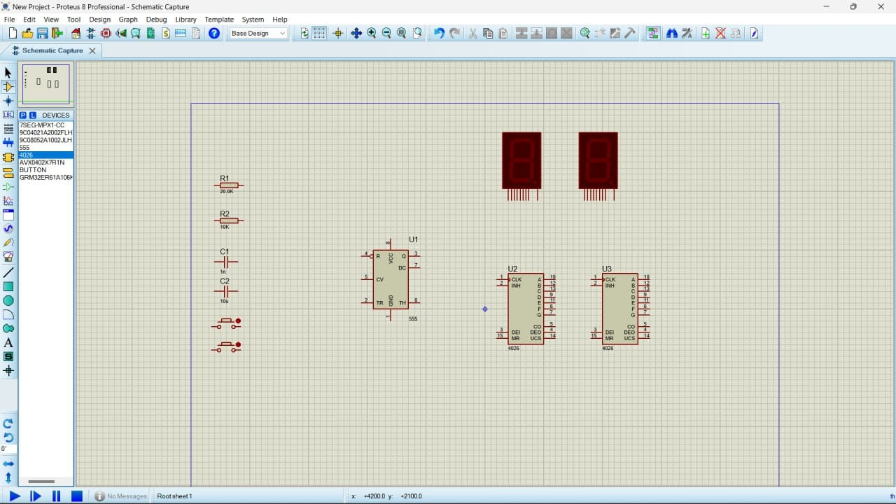

***Pin Diagram of 4026***

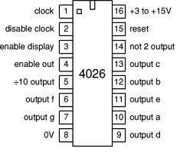

***The cost of the circuit is around 300/-.***

* ***We learned the usage of the 4026 IC,it is a decade counter with decoder 7 segment.This will convert the input into numeric display and can be seen on 7 segment display. It requires around 10v & 5mA current to directly drive the seven segment display.***

***This 4026 makes the circuit optimize by reducing the connections that makes it complex & hard to implement physically***

***The circuit can be used as a clock. In this circuit the counter will advance after one minute or after every one second depending on the value of resistor selected.***

***It can be used while cooking or while doing exercise or by students preparing for competitive exams.***

***This circuit is based on***[***NE555***](https://www.engineersgarage.com/electronic-components/ne555-timer-ic-datasheet)***and CD4026, which is a Johnson counter IC commonly used in digital display.***

***It has a 5 stage Johnson decade counter with decoder which converts the Johnson code to a 7 segment decoded output.***

***It means input will be converted into numeric display which can be seen on***[***7 segment display***](https://www.engineersgarage.com/electronic-components/7-segment-display)***.***

***It can be used in various applications like in 7 segments decimal display circuit, in clocks, timer etc. Advantage of 4026 counter-***

***It contains counter and 7 segment decoding in one package.***

***●    It can be easily interfaced with 7 segment types.***

***●    Ideal for low power display.***

***●    Operated at wide range of temperature from 5V to 20V.***

***●    The big advantage of the 4026B counter IC is that it can drive a 7-segment display without needing a decoder driver IC.***

***PIN DIAGRAM OF SEVEN SEGMENT***

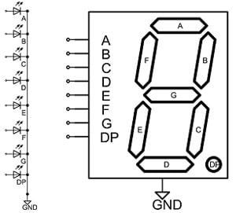

The **seven segment displays** are one of the oldest & efficient types of display used in electronics applications. These displays have 8 LEDs inside it arranged in a manner. These 8 LEDs are separated into each segment which can be named as a, b, c, d, e, f, g, DP (decimal point) as shown in the picture below.

These entire 8 LEDs have one end of their pins pulled out of the module as shown below and the other ends are connected together and pulled out as the Common pin. So to make patterns like numbers (0 – 9) or alphabets we just need to power common along with the other segment pin

PIN DIAGRAM OF TIMER 555

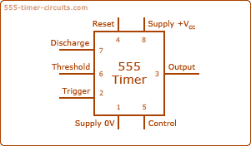

555 timer is used in almost every electronic circuit today. A 555 timer works as a [flip-flop](https://www.electronicsforu.com/technology-trends/learn-electronics/flip-flop-rs-jk-t-d) or as a multi-vibrator, it has a particular set of configurations. Some of the major features of the 555 timers would be,

* It operates from a wide range of power ranging from +5 Volts to +18 Volts supply voltage.
* Sinking or sourcing 200 mA of load current.
* The external components should be selected properly so that the timing intervals can be made into several minutes along with the frequencies exceeding several hundred kilohertz.
* The output pin of a 555 timer can drive a transistor-transistor logic (TTL) due to its high current output.
* It has a temperature stability of 50 parts per million (ppm) per degree Celsius change in temperature which is equivalent to 0.005 %/ °C.
* The duty cycle of the timer is adjustable.
* Also, the maximum power dissipation per package is 600 mW, and its trigger pulse and reset inputs have logic compatibility.

**CIRCUIT DESIGN**

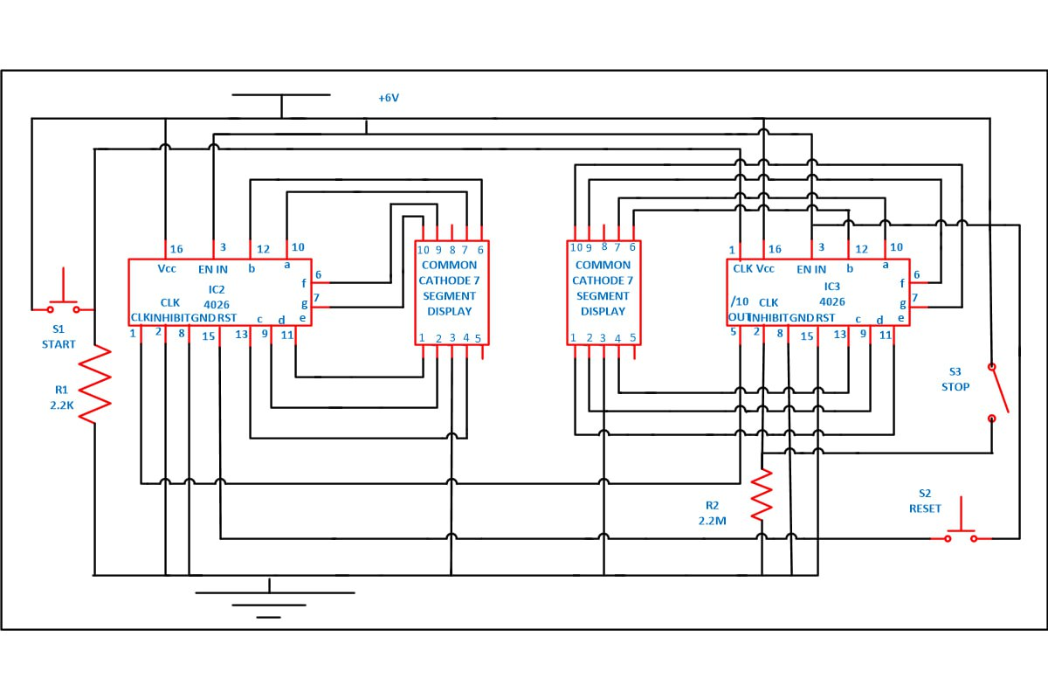

Flowchart of Circuit

***Alternate Designs***

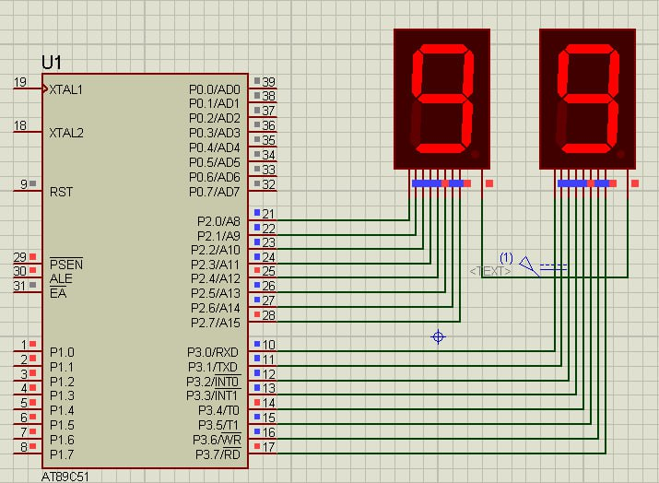

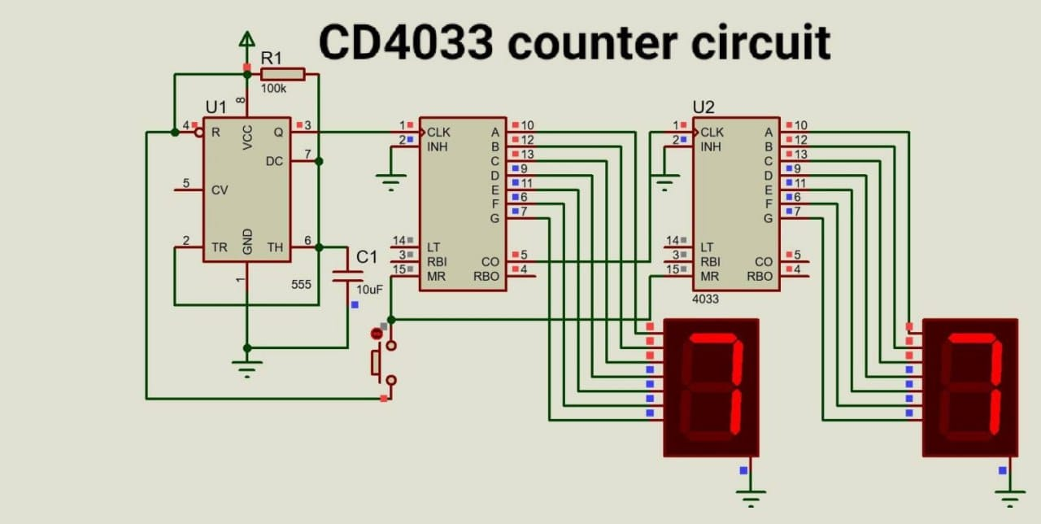

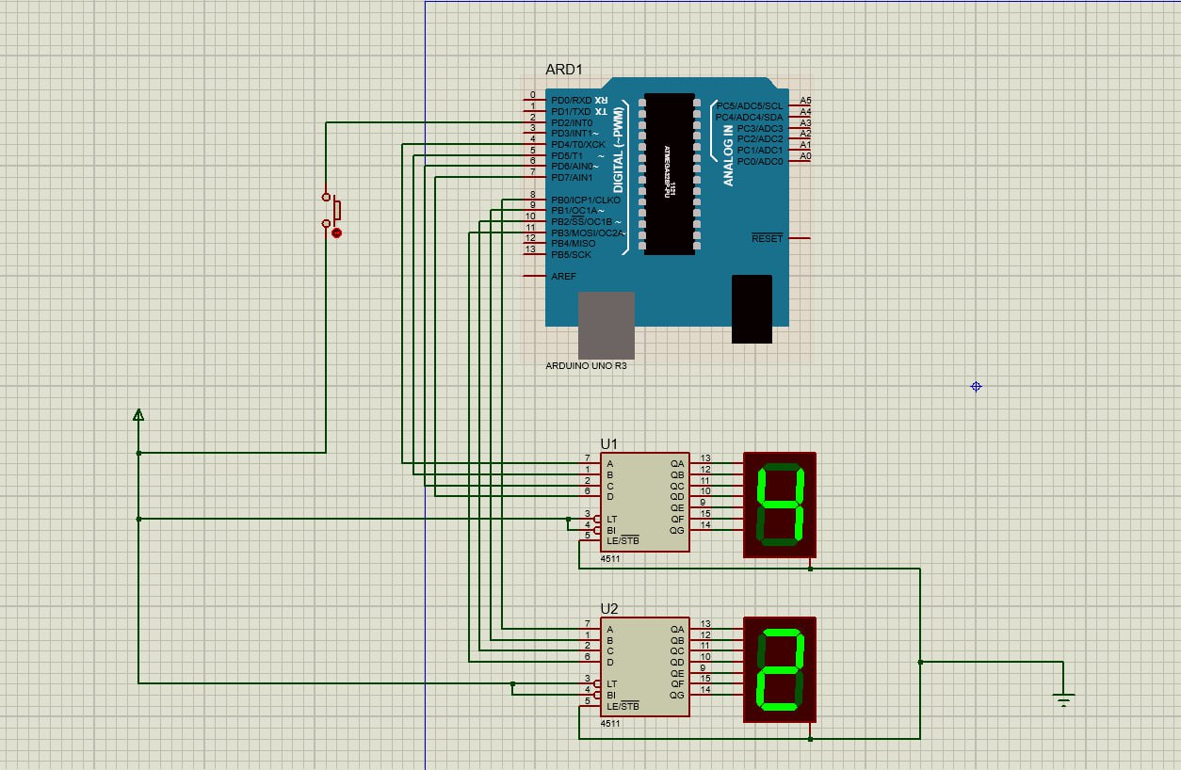

***Simulation of the circuit design***

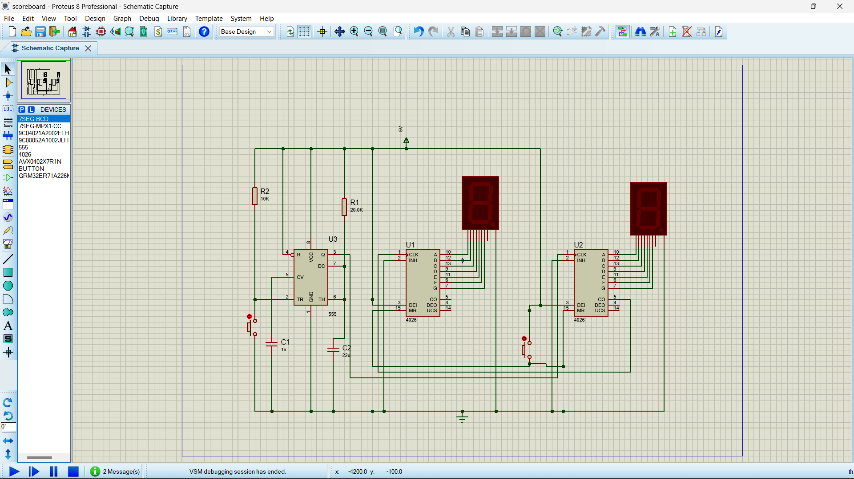

***WORKING CIRCUIT SNAPSHOTS***



